AI-DRIVEN REVIEW ANALYTICS FOR PRODUCT ENHANCEMENT
Electrical & Computer Engineering & Computer Science (ECECS)





Contents
AI-Driven Review Analytics For Product Enchancement.......................2
Executive Summary.............................................................................2
Technical Report..................................................................................3
Highlights of Project............................................................................3
Submitted on:.....................................................................................3
Abstract..............................................................................................4
Methodology......................................................................................6
Results Section..................................................................................10
Discussion..........................................................................................13
Conclusion.........................................................................................14
Contributions/References..................................................................14

AI-DRIVEN REVIEW ANALYTICS FOR PRODUCT ENHANCEMENT

Executive Summary
This executive summary encapsulates the key findings and implications derived from the comprehensive analysis of the Amazon Alexa reviews dataset. The investigation spans exploratory data analysis (EDA), text analysis, and sentiment prediction, with a focus on unraveling customer sentiments and patterns within the review.
The dataset, comprising Amazon Alexa product reviews, is robust and well-structured, containing essential columns such as rating, date, product variation, feedback, and the actual review text. With no missing values, the dataset forms a solid foundation for subsequent analyses.


Team Members:  Akash Vemula - Data Scientist  Gowtham - Data Engineer  Varun Yadhav - Data Analyst | Questions?  Contact : avemu13@unh.newhaven.edu  gcheb1@unh.newhaven.edu  vdhoo1@unh.newhaven.edu

Technical Report
AI-Driven Review Analytics for Product Enhancement

Highlights of Project
The AI-Driven Review Analytics for Product Enhancement project aims to analyze Amazon Alexa customer reviews using machine learning to determine sentiment polarity and extract meaningful insights that can inform product improvement strategies.
A dataset of over 3,000 verified reviews—including star ratings, product variations, and user feedback—was sourced and prepared for analysis. Preprocessing involved stop word removal, punctuation handling, tokenization, and feature extraction using TF-IDF vectorization to convert textual data into numerical representations.
Three supervised learning algorithms were used: Naive Bayes, Decision Tree, and Random Forest. These models were trained to classify sentiments as positive or negative. Evaluation showed that Random Forest performed best, achieving 94.13% accuracy, followed by Decision Tree (93.33%) and Naive Bayes (90.95%). Hyperparameter tuning further enhanced the models’ effectiveness.
The project also included visualization of trends such as sentiment distribution, keyword frequency, and monthly review activity. These visual insights help businesses quickly understand customer perceptions and areas of concern.
To enable scalability and real-world application, the solution was designed for cloud deployment on AWS. Key services include Amazon S3 for storage and EC2 for hosting the app, with optional use of AWS Lambda and API Gateway for serverless prediction endpoints.
This project demonstrates how AI and cloud computing can be combined to automate sentiment analysis, reduce manual workload, and support data-driven decision-making for product development.

Submitted on: 04/31/2025

Abstract
This project aims to leverage machine learning and natural language processing (NLP) to automate sentiment analysis on customer reviews of Amazon Alexa products. With a dataset comprising over 3,000 verified reviews—containing star ratings, textual feedback, and product variations—the project seeks to classify customer sentiments as positive or negative and uncover patterns that inform product evaluation and improvement.
To accomplish this, three supervised learning models—Naive Bayes, Decision Tree, and Random Forest—were implemented. The data underwent rigorous preprocessing, including tokenization, stop word removal, and TF-IDF vectorization for feature extraction. Model performance was evaluated using accuracy, precision, recall, and F1-score, with Random Forest achieving the highest accuracy (94.13%).
Beyond modeling, the project also includes a cloud-ready deployment strategy using AWS services such as Amazon S3 and EC2, enabling real-time sentiment prediction via a web application or API. Visualizations were developed to explore review distributions, sentiment trends, and common keywords, offering actionable insights for product teams. This project demonstrates how scalable AI-driven analytics can improve customer experience, guide product refinement, and enhance business decision-making.
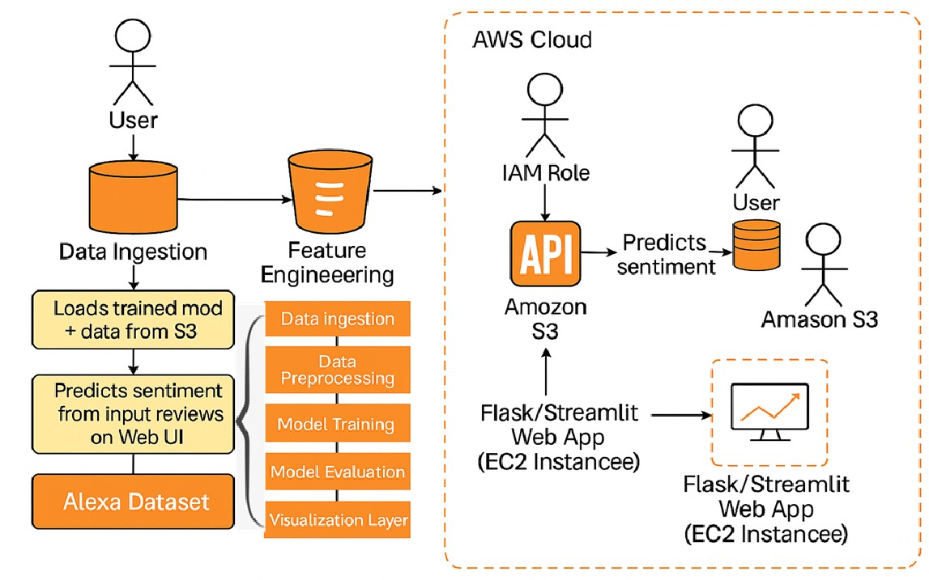
Introductory Section
Customer reviews are a vital source of feedback for companies aiming to improve their products and services. With the rapid adoption of smart devices like Amazon Alexa, thousands of users share their experiences online, providing insights into product satisfaction, functionality, and areas for enhancement. However, manually analyzing such a large volume of reviews is time-consuming and inefficient, making it necessary to adopt automated approaches.
This project addresses that challenge by leveraging machine learning and natural language processing (NLP) to perform sentiment analysis on Amazon Alexa customer reviews. Using a dataset of over 3,000 verified reviews—including ratings, product variations, and written feedback—we trained models to classify sentiments as positive or negative. The outcome is an AI-driven system that helps organizations quickly interpret customer opinions, uncover patterns, and make informed decisions to improve product offerings.
Review of available research
Sentiment analysis has become a widely researched area in natural language processing (NLP), particularly for applications involving product reviews and customer feedback. Studies have shown that machine learning algorithms such as Naive Bayes, Decision Trees, and Random Forests are effective in classifying sentiment when paired with preprocessing techniques like stop word removal and TF-IDF vectorization. These models have been extensively tested on datasets from various domains, demonstrating their ability to convert unstructured textual data into meaningful sentiment classifications.

Despite this progress, limited research exists specifically around sentiment analysis for voice-assisted devices like Amazon Alexa. Much of the existing literature focuses on general product reviews or social media sentiment, leaving a gap in domain-specific applications. Our project addresses this gap by applying proven machine learning methods to Amazon Alexa reviews, exploring how effectively these models can capture sentiment in a context where usability, technical performance, and customer satisfaction are deeply intertwined.

Methodology
Title of the Project
AI-Driven Review Analytics for Product Enhancement

Business Understanding
The goal of this project is to automate the analysis of Amazon Alexa customer reviews by predicting sentiment polarity. By identifying positive and negative sentiments at scale, businesses can gain insights into customer satisfaction, improve product features, and make data-driven decisions.

Data Understanding
The dataset, sourced from Kaggle, contains over 3,000 verified Amazon Alexa product reviews. Each entry includes a textual review, customer feedback, star rating, date, and product variation. The dataset was clean and free of missing values, offering a reliable basis for analysis.

Data Preparation
Preprocessing was conducted using standard NLP techniques. This included converting text to lowercase, removing punctuation and stop words, and applying tokenization. TF-IDF vectorization was used to transform the cleaned text into numerical features suitable for machine learning models.

Modeling
Three supervised learning algorithms—Naive Bayes, Decision Tree, and Random Forest—were implemented to classify sentiments. These models were selected based on their proven effectiveness in text classification tasks, as highlighted in prior research.

- Naive Bayes Classifier
- Naive Bayes is a probabilistic machine learning algorithm based on Bayes' theorem, utilizing probability theory for classification tasks.
- Beyond text classification, Naive Bayes is applied in various fields, including email filtering, medical diagnosis, and document categorization. It adapts well to diverse domains and is particularly effective with large datasets.
- It assumes feature independence, meaning the presence of a particular feature is considered independent of the presence of other features.
- Widely used in text classification tasks like spam detection and sentiment analysis due to its efficiency with high-dimensional data.
- Known for its simplicity and computational efficiency, requiring a small amount of training data for effective model building.

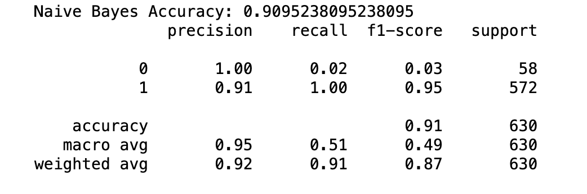

- Random Forest Classifier:
- Random Forest is an ensemble learning algorithm that builds a multitude of decision trees during training and merges them for more accurate and stable predictions.
- Provides a measure of feature importance, helping in identifying the most influential features in the dataset.
- It relies on the foundation of decision trees, where each tree independently contributes to the final prediction.
- During the construction of each tree, a random subset of features is considered for each split, enhancing diversity and reducing overfitting.
- Random Forest employs a technique called bagging (Bootstrap Aggregating), creating multiple subsets of the training data to train individual trees.
- Known for its high accuracy and robustness against overfitting, making it effective for complex datasets and minimizing the risk of individual tree biases.
- Applied in various domains, including classification and regression tasks, due to its adaptability and ability to handle diverse data structures.

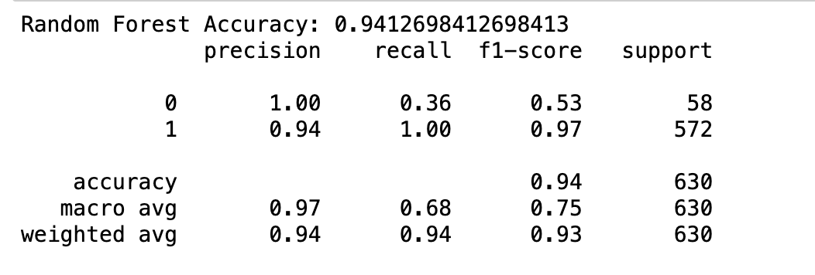
- Decision Tree
- A Decision Tree is a tree-like structure where each node represents a decision based on a particular feature.
- The tree structure involves hierarchical decision-making, with the root node making the initial decision and subsequent nodes refining those decisions.
- At each node, the dataset is split based on a chosen feature and a corresponding criterion, such as Gini impurity or information gain.
- Decision Trees are used for both classification and regression tasks, making predictions by traversing the tree from the root to a leaf node.
- Known for its interpretability, Decision Trees provide a clear and visual representation of decision-making processes, making them accessible for non-experts.
- Decision Trees are prone to overfitting, capturing noise in the training data. Techniques like pruning are often applied to mitigate this issue.
- Decision Trees form the basis for ensemble methods like Random Forests, combining multiple trees to improve accuracy and robustness.
- Decision Trees provide a measure of feature importance, indicating the contribution of each feature to the decision-making process.

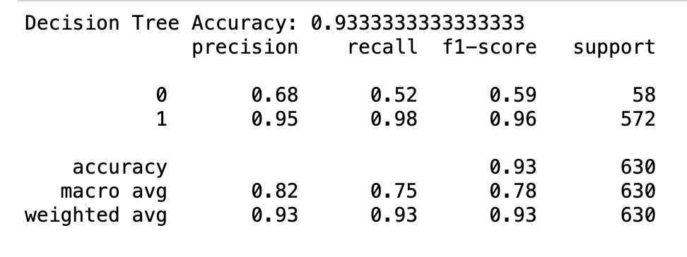

Evaluation
Model performance was assessed using metrics such as accuracy, precision, recall, and F1-score. Random Forest achieved the highest accuracy (94.13%), followed by Decision Tree (93.33%) and Naive Bayes (90.95%). Hyperparameter tuning was applied to optimize each model's performance.

Results Section

Data Engineering Pipeline
Data Ingestion:
- Source: Kaggle
- Tool: Python with Pandas for reading and cleaning data

Data Storage:
Storage: Amazon S3 bucket for dataset and serialized model files

Data Processing:
- Tools: Scikit-learn for model training
- NLP Libraries: NLTK, scikit-learn’s TF-IDF for text vectorization and transformation

Data Consumption (Your App):
- Application: Flask or Streamlit used to create an interactive web interface for inputting review text and returning predictions
- Features: Real-time sentiment prediction, upload review file option, visualization panels

Model Deployment:
- Model serialized using joblib and loaded into Flask/Streamlit
- Hosted on AWS EC2 instance with support for batch and real-time predictions
- Optional deployment via AWS Lambda + API Gateway for serverless API exposure

Data Visualization:
- Tools: Matplotlib, Seaborn, and WordCloud for generating charts and insights
- Visuals Included: Rating distribution, feedback polarity distribution, top keywords, product-wise sentiment breakdown

Deployment:
- Infrastructure: AWS EC2 (Ubuntu 22.04), Python 3.x environment
- Port opened for public access (5000 or 8501)
- S3 used to decouple storage from compute
- GitHub for version control and project documentation

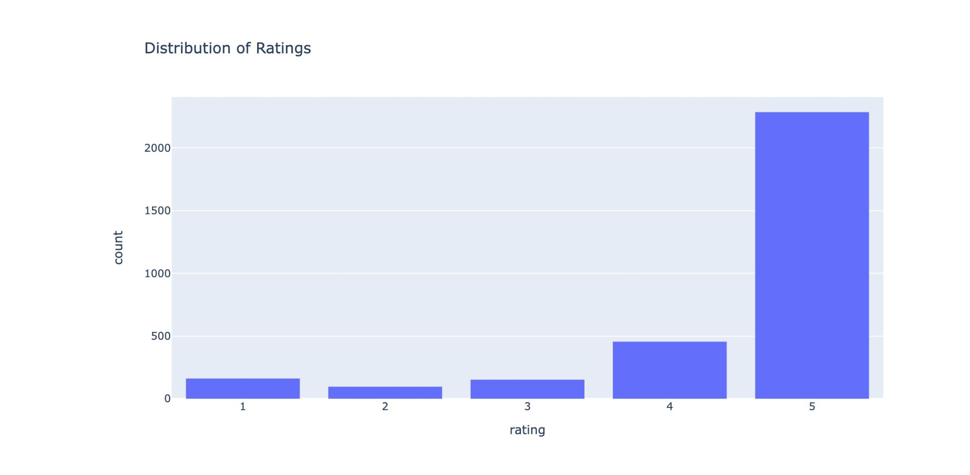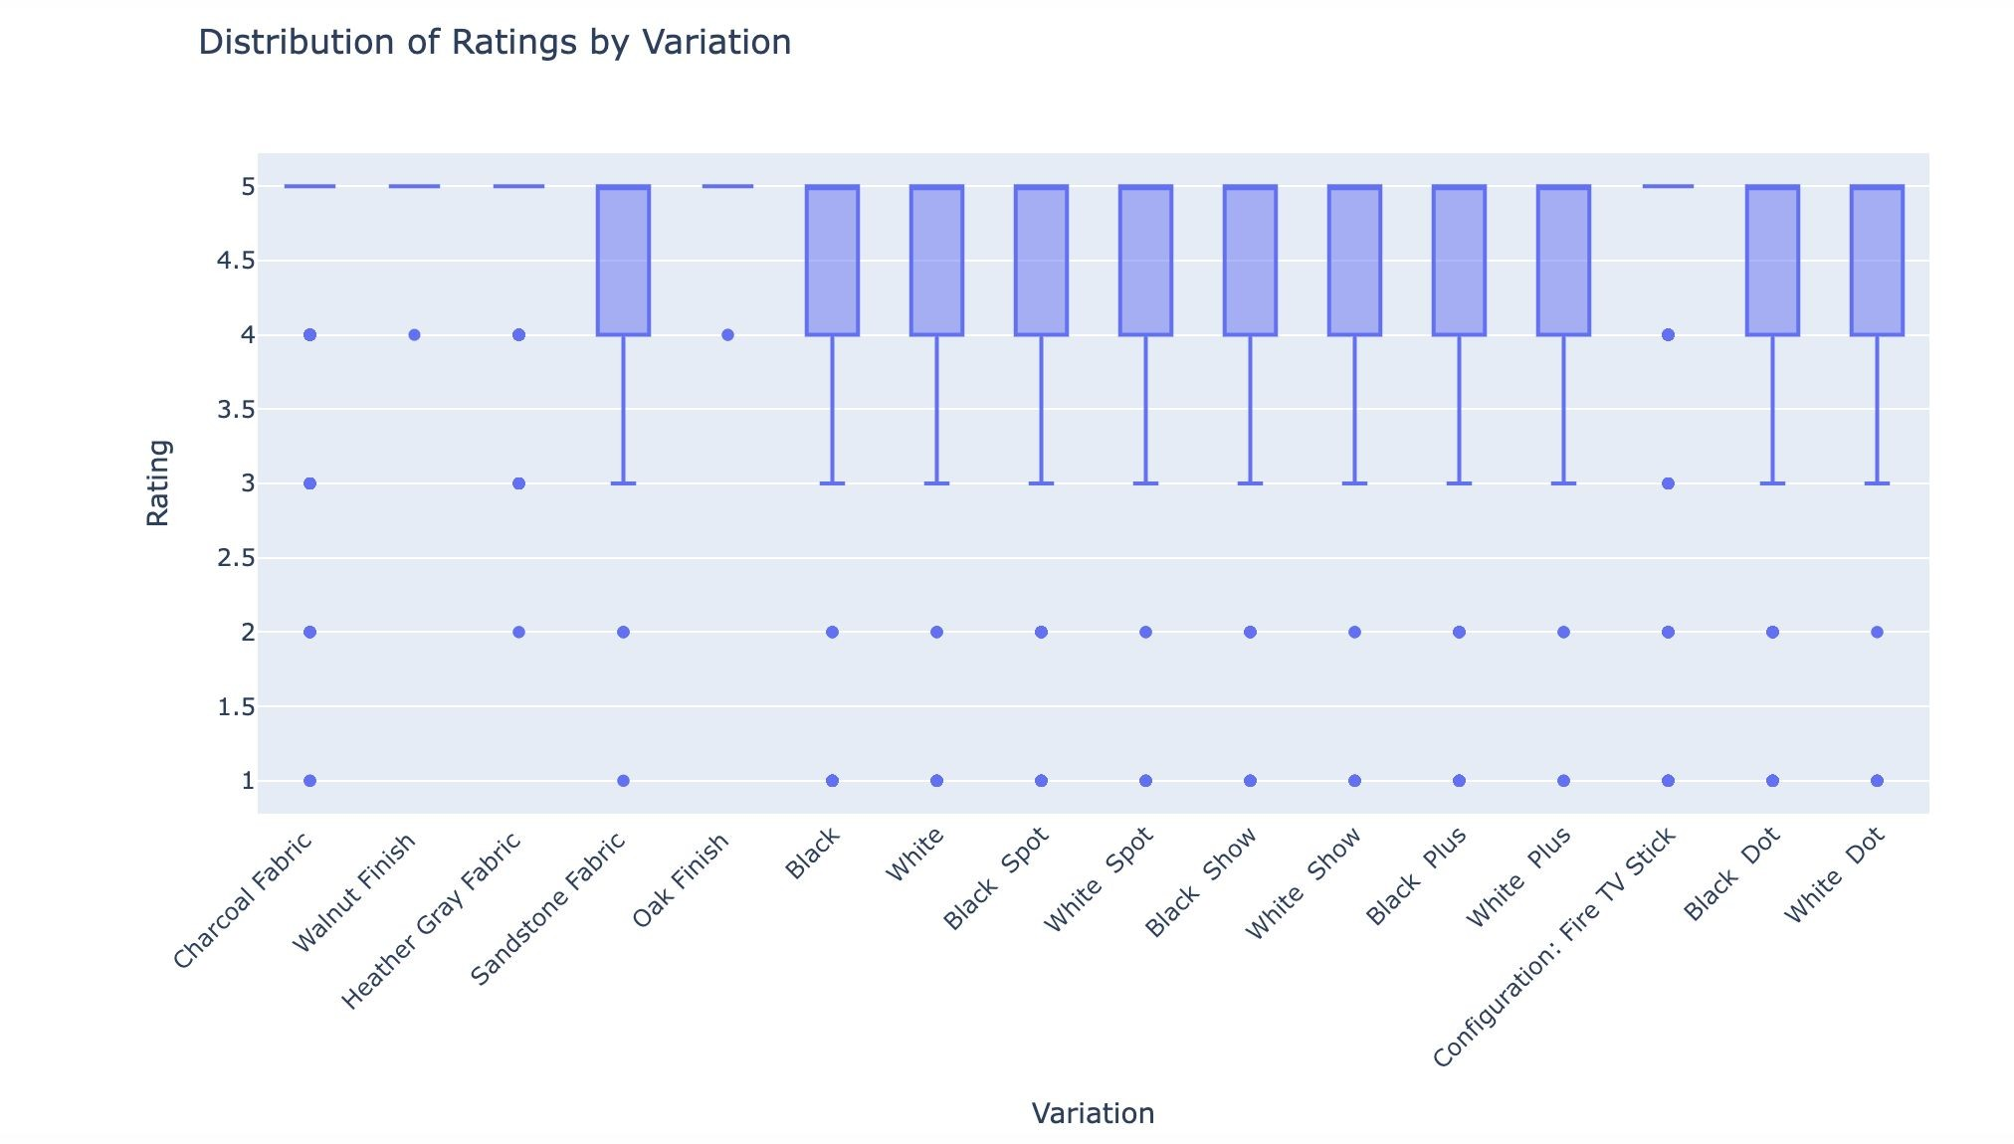
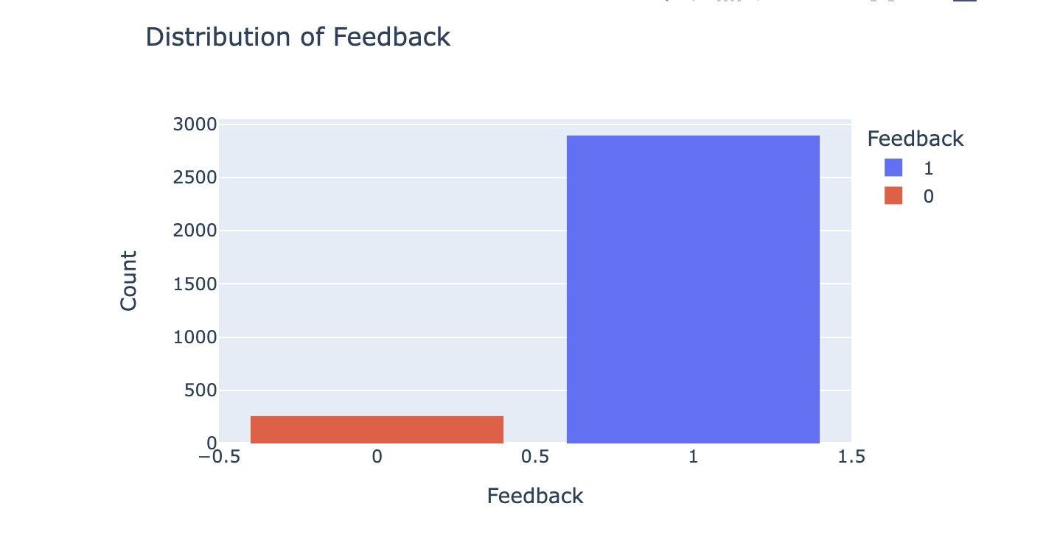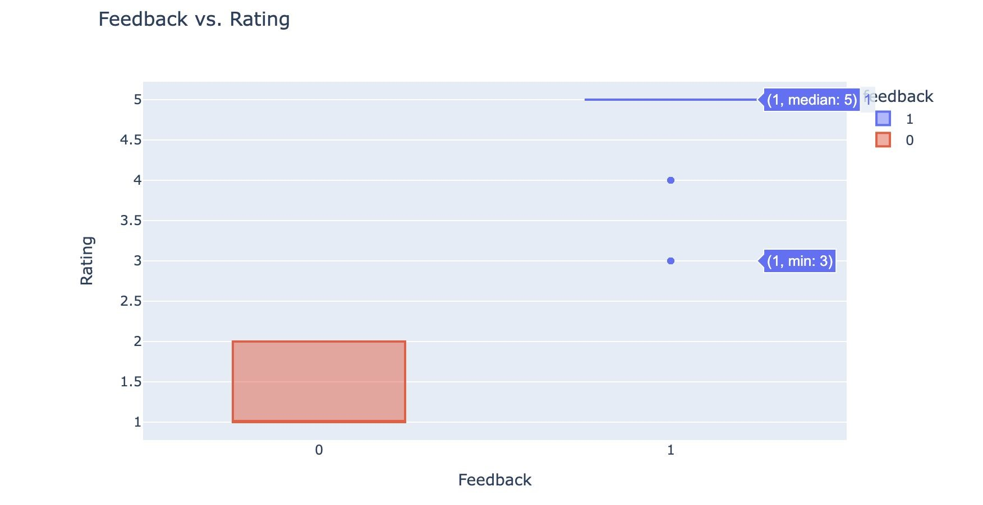

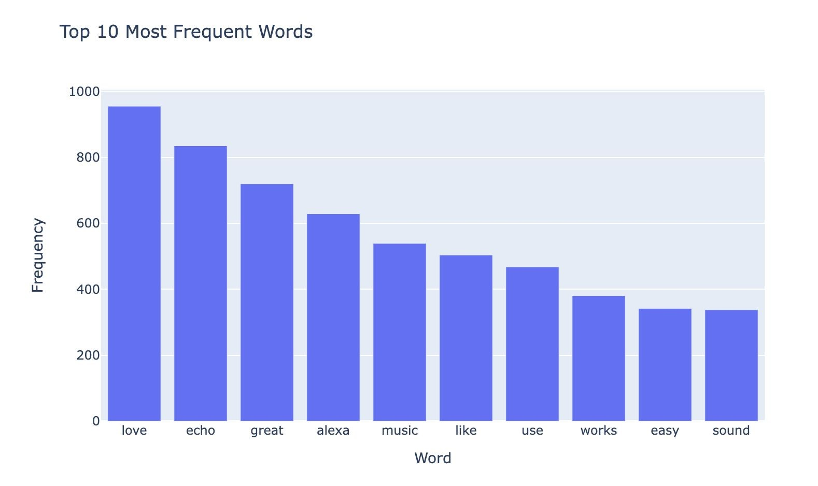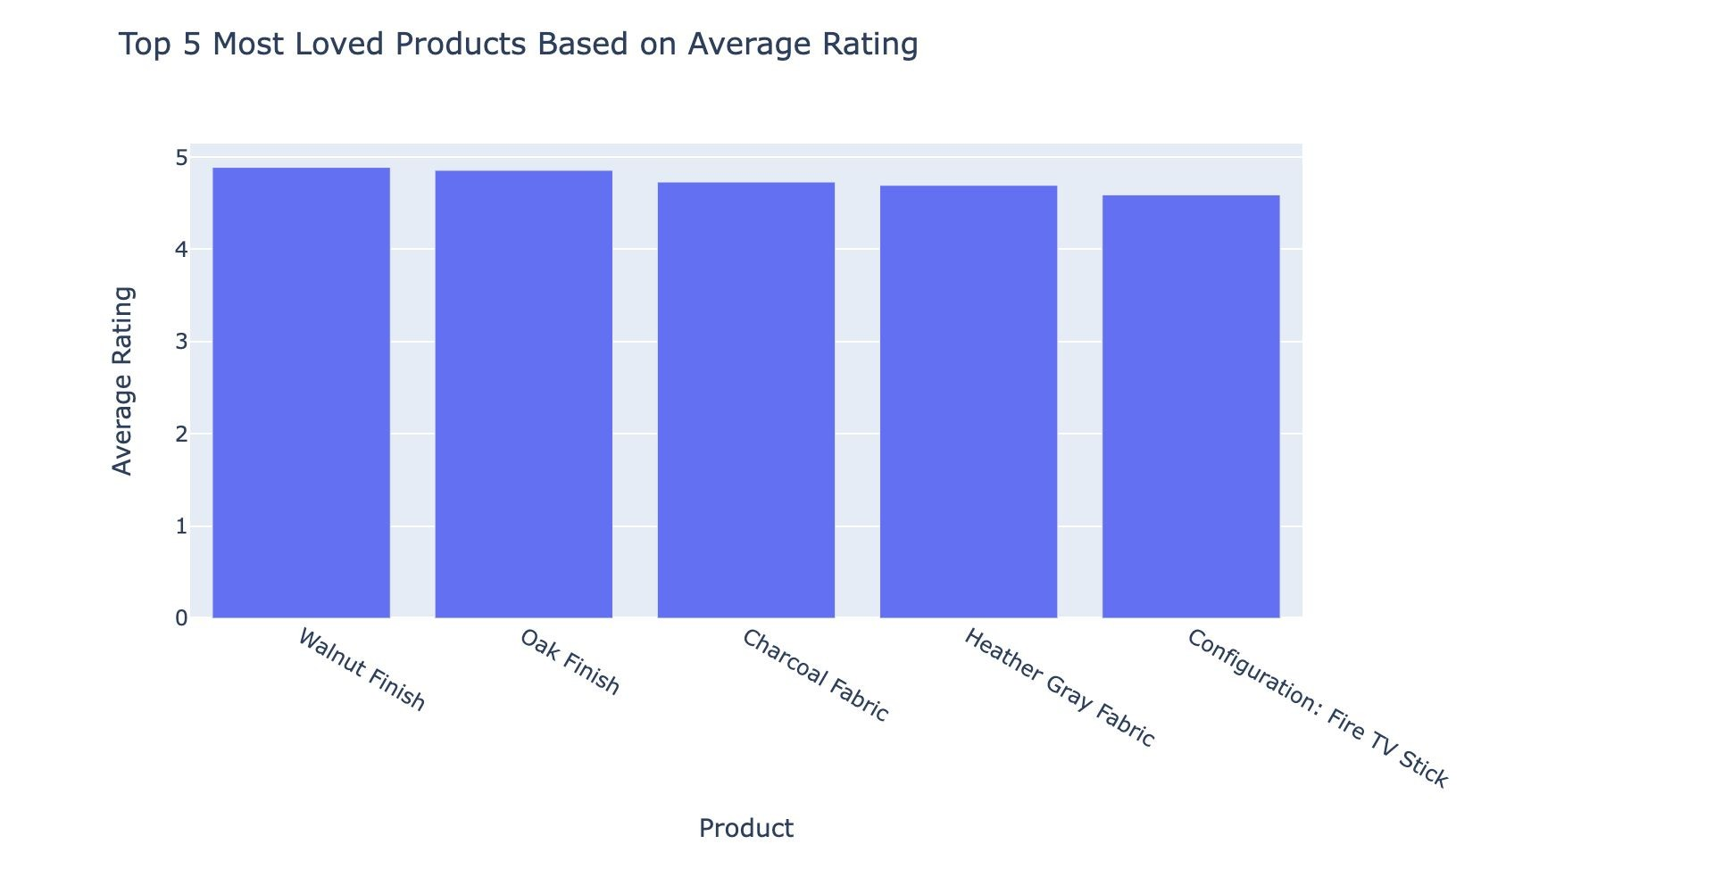

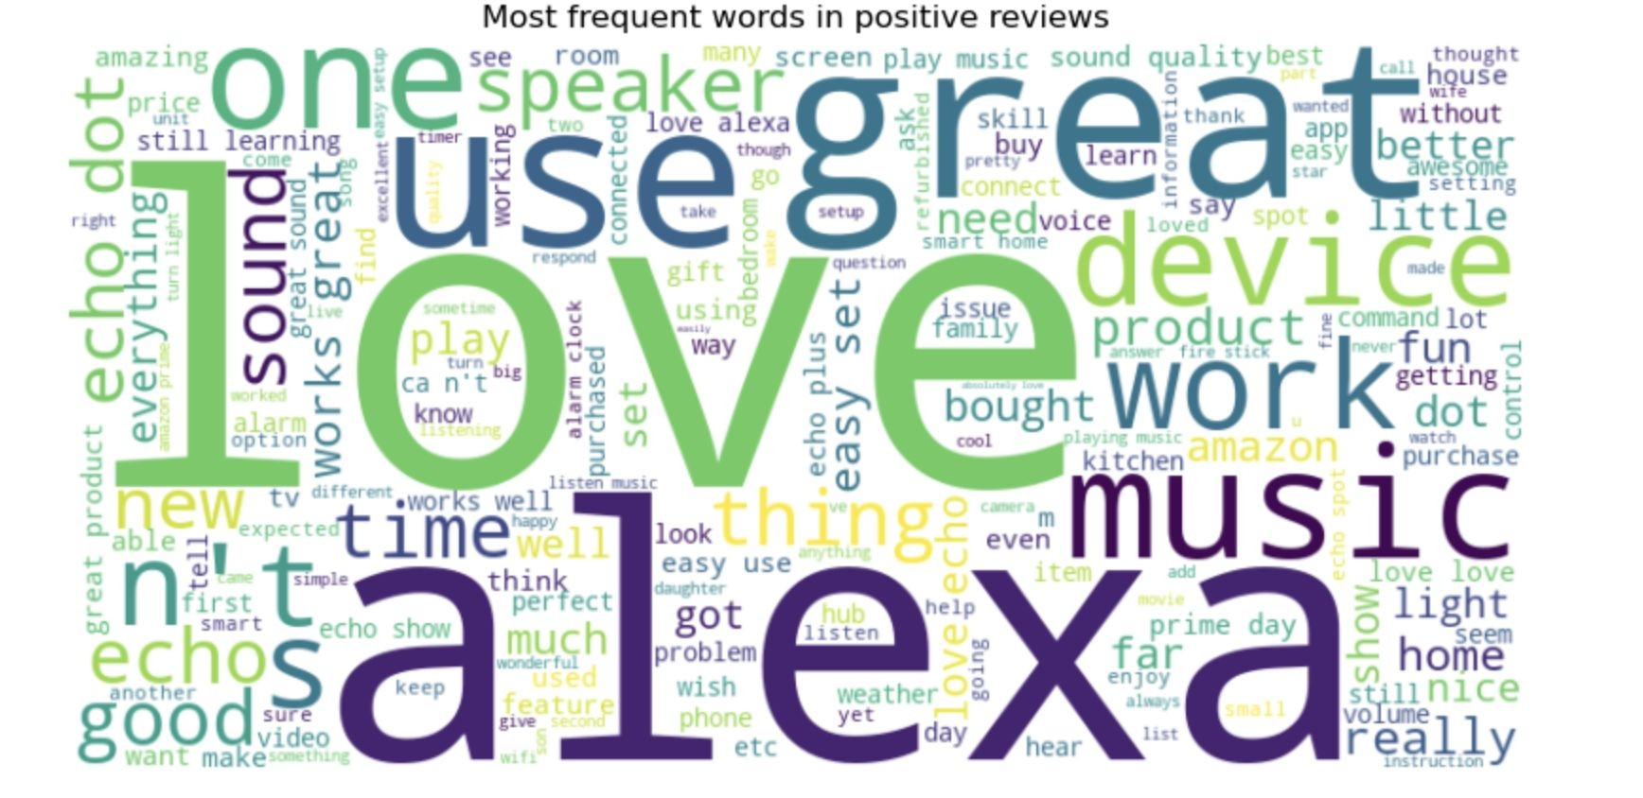

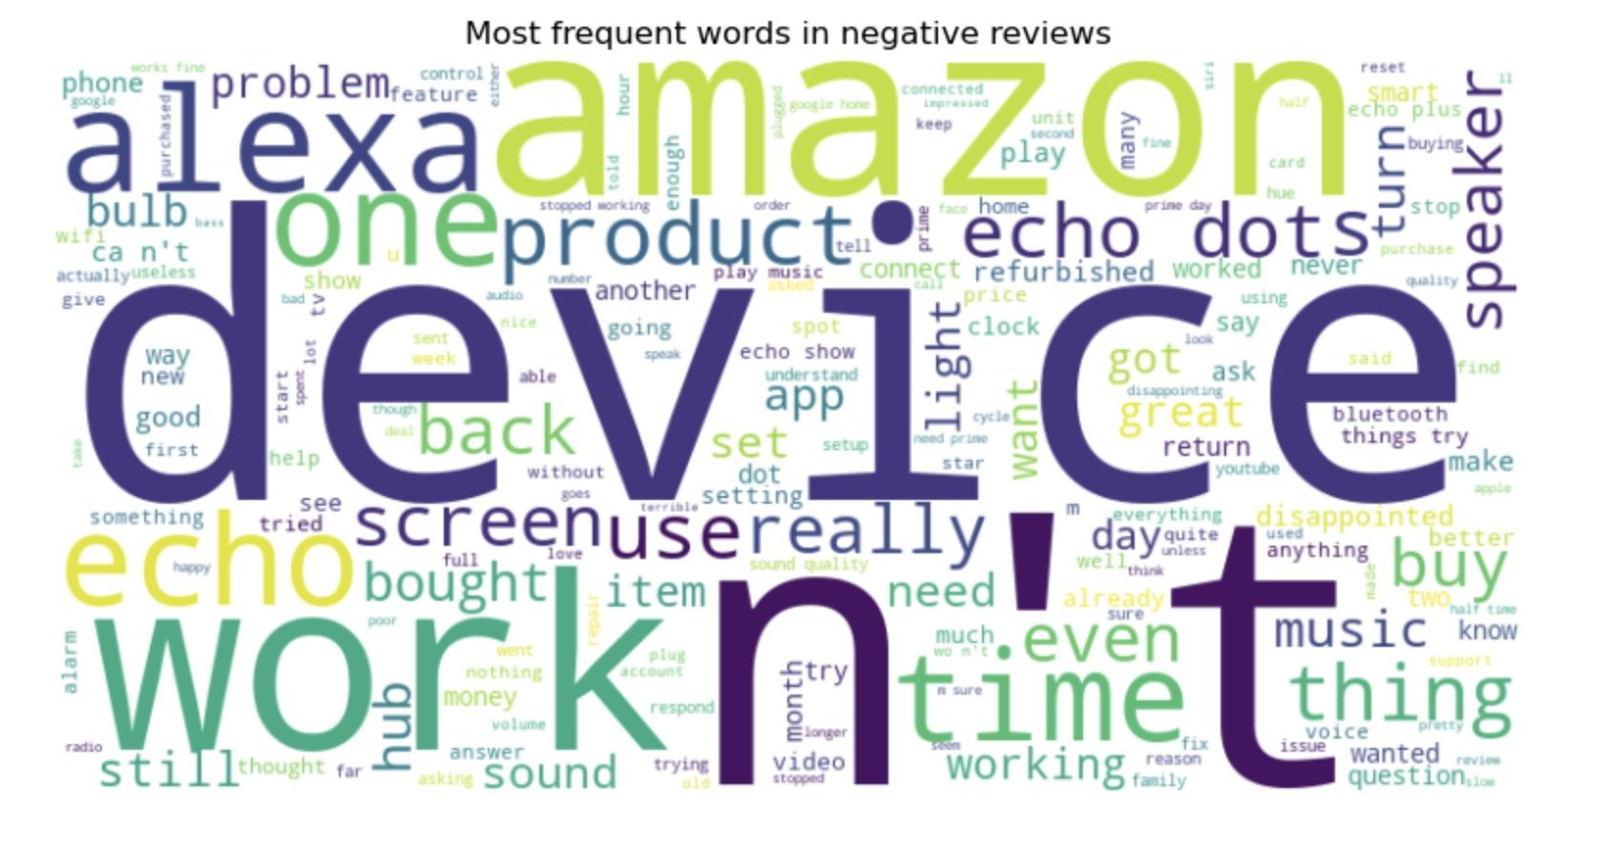

Discussion
The goal of this project was to determine whether machine learning models could effectively classify customer sentiment based on Amazon Alexa product reviews, and to identify which model performs best in this context. The results confirmed that machine learning, particularly ensemble methods like Random Forest, can reliably predict sentiment with high accuracy, reaching over 94%. These findings directly address the research question and fill the identified gap in sentiment analysis applied specifically to voice-assisted device reviews.
While the high accuracy demonstrates the strength of our approach, the discussion must also acknowledge limitations. The dataset, though clean and structured, represents a relatively small sample size of just over 3,000 reviews. Additionally, customer sentiment is often nuanced—simple positive or negative labels may not capture mixed feedback or contextual emotion. Although our models performed well in binary classification, they may struggle with subtleties like sarcasm or ambiguous wording. Future work could incorporate deep learning models such as LSTM or transformers, and expand classification to include neutral or multi-level sentiment.
Despite these caveats, our project contributes a practical, cloud-deployable sentiment analysis solution for customer review mining. It provides a scalable framework that businesses can use to monitor public sentiment, detect trends, and improve their products through data-driven insights.

Conclusion
In summary, an Amazon Alexa review classifier is a machine learning model employing natural language processing techniques to assess the quality of Amazon Alexa products. Building the classifier involves utilizing various algorithms like decision trees, Naive Bayes, and random forest, necessitating a meticulously labeled dataset of Amazon Alexa reviews.
The classifier's accuracy is contingent on factors such as the dataset's quality and size, algorithm selection, and hyperparameter choices. While achieving 100% accuracy is challenging for any classifier in product evaluation, the development of Amazon Alexa review classifiers serves as a valuable tool in indicating the actual quality of Amazon Alexa products to users.

Contributions/References
https://www.analyticsvidhya.com/blog/2021/08/decision-tree-algorithm/#:~:text=A%20decision%20tree%20algorithm%20is,each%20node%20of%20the%20tree.
https://www.analyticsvidhya.com/blog/2021/06/understanding-random-forest/
https://www.analyticsvidhya.com/blog/2017/09/naive-bayes-explained/
https://www.kaggle.com/datasets/sid321axn/amazon-alexa-reviews

